**Problem Statement**

**Product Dissection for top leading Platforms**

Welcome to this case study on dissecting and designing products for top leading platforms. In this case study, you will delve into the intriguing world of schema design for a prominent platform of your choice. Your task is to choose a top leading platform, research its features, and meticulously craft a schema design that encapsulates the essence of its functionality. By focusing on key entities, attributes, and relationships, you will gain invaluable insights into how data architecture drives the platform's effectiveness.

**Step 1: Choose a Leading Platform**

Select a leading platform of your choice, which could span various domains such as social media, e-commerce, finance, or any other industry. This choice will form the foundation of your exploration into its schema design.

**Step 2: Research:**

Thoroughly research the platform you have selected. Investigate its core features, functionalities, and user interactions. Identify the top features that define its user experience and contribute significantly to its popularity.

**Step 3: Product Dissection and Real World Problems solved by the platform**

In this step, you will meticulously analyse the platform's standout features and how they provide innovative solutions to real-world challenges. By identifying key functionalities that resonate with users, you'll unravel how the platform effectively addresses problems and enhances user experiences. This dissection will serve as the foundation for understanding how the schema design aligns with the platform's core objectives.

**Step 4: Case Study on the real world problems and approach to solving them**

In this pivotal step, you will expand on the real-world challenges uncovered in Step 3 through a comprehensive case study. Delve into specific instances where users encountered difficulties and showcase how the platform's unique features provided effective solutions. By dissecting the approach taken by the platform to overcome these challenges, you'll gain a deeper appreciation for the platform's user-centric design philosophy and how it shapes the schema design.

**Step 5: Schema Design Based on Top Features**

Based on the features you have identified, craft a schema design that reflects the platform's data structure. Focus on the key entities, attributes, and relationships that underpin the chosen features. Your schema should capture the essence of how the platform organises and utilises its data.

**Step 6: Rationale Behind the Design**

While creating the schema design, consider the rationale behind the platform's choices. Reflect on why certain entities and relationships were chosen and how they align with the platform's goals. This will help you understand the strategic decisions driving the schema's architecture.

**Step 7: Create an ER Diagram**

Utilise tools like the Miro platform or similar applications to create an illustrative Entity-Relationship (ER) diagram. This diagram should vividly depict the entities, attributes, and relationships present within your schema design. The ER diagram will serve as a visual representation of your insights.

**Step 8: Presentation of Findings**

Present your findings in a clear and concise manner. Showcase your understanding of how the schema design impacts the platform's functionality and user experience. Explain how your chosen features are integrated into the schema and how the schema's structure supports the platform's objectives.

**Task Details:**

1. **Answer Submission:** Your submission should include well-structured solutions for all provided questions related to product schema designs.
2. **Video Creation:** Create an informative and engaging video where you thoroughly explain the Case Study.
3. **Depth and Clarity:** Ensure your solutions are detailed and showcase your understanding of product schema design principles. Similarly, in the video, provide clear explanations that are easy to understand for a wide audience.
4. **Creativity Encouraged:** You are welcome to utilise visuals, diagrams, or creative elements to enhance the clarity and impact of your explanations.

**Note:**

1. Duplicate this document and proceed to write your solutions and prepare your video.
2. Include the video link in this document before final submission.

Best of luck in completing this project and showcasing your prowess in dissecting and designing product schema for leading platforms! **For reference, we have also conducted a case study on Instagram, which you can find below. This case study will provide you with valuable insights into how schema design plays a pivotal role in shaping the functionality and success of a prominent platform.**



**Product Dissection for PhonePe**

**Company Overview: PhonePe**

**Introduction:**

**PhonePe is a leading financial technology company based in India, offering a comprehensive digital payments platform. Founded in 2015, PhonePe has emerged as a key player in the country's digital payment landscape, providing secure, convenient, and innovative solutions to millions of users.**

**Mission:**

**Our mission at PhonePe is to simplify and enhance the way people transact, making digital payments accessible, fast, and secure for everyone. We aim to drive financial inclusion and empower users by leveraging cutting-edge technology.**

**Key Services:**

* **1. Digital Payments:**
  + **PhonePe offers a seamless and user-friendly digital payment experience, allowing users to make transactions with ease.**
  + **Users can perform a wide range of transactions, including mobile recharges, bill payments, and online shopping.**
* **2. Unified Payments Interface (UPI):**
  + **As a UPI-enabled app, PhonePe facilitates instant money transfers between users' bank accounts using a simple and secure interface.**
  + **UPI has become a preferred mode of payment for individuals and businesses, and PhonePe plays a crucial role in its widespread adoption.**
* **3 . Innovative Features:**
  + **PhonePe continuously introduces innovative features to enhance user experience, such as QR code payments, in-app insurance purchases, and mutual fund investments.**

**Merchant Services:**

* + **PhonePe supports merchants by providing QR code solutions for accepting digital payments, catering to both online and offline businesses.**

**Technology and Security:**

**PhonePe leverages state-of-the-art technology to ensure the security and integrity of every transaction. We employ robust encryption protocols and adhere to the highest industry standards to safeguard users' financial information.**

**User Base:**

**PhonePe has garnered a substantial user base, reflecting the trust and confidence users place in our platform. Our commitment to reliability, security, and customer satisfaction has contributed to the rapid growth of our user community.**

**Partnerships and Collaborations:**

**PhonePe actively collaborates with various businesses and financial institutions to expand its services and provide users with a comprehensive financial ecosystem.**

**Vision for the Fut**

**Looking ahead, PhonePe envisions becoming a trailblazer in the global digital payments landscape. We will continue to innovate, collaborate, and create value for our users, fostering financial inclusion and contributing to the digital transformation of economies.**

### **Product Dissection and Real-World Problems Solved by PhonePe:**

**Product Dissection: PhonePe**

**1. Digital Payments Platform:**

* **Features:**
  + **Seamless Fund Transfers: PhonePe enables users to transfer funds instantly between bank accounts using the Unified Payments Interface (UPI).**
  + **Bill Payments: Users can pay utility bills, mobile recharges, and other bills directly through the app.**
  + **In-App Shopping: PhonePe facilitates secure transactions for online shopping within the app.**
  + **QR Code Payments: The platform supports quick and hassle-free payments through QR codes.**
* **User Experience:**
  + **Intuitive Interface: The app provides a user-friendly interface for effortless navigation.**

**Quick Transaction Processing:**

**Users can complete transactions swiftly, contributing to a seamless experience.**

* **Innovations:**
  + **Mutual Fund Investments: PhonePe offers users the option to invest in mutual funds directly through the app.**
  + **In-App Insurance: Users can purchase insurance policies within the app, simplifying the insurance-buying process.**

**2. Merchant Solutions:**

* **QR Code Solutions:**
  + **PhonePe provides QR code solutions for merchants to accept digital payments.**
  + **Merchants can leverage the platform for both online and offline transactions.**

**Business Integrations:**

* **Integration with various businesses allows users to make payments at a wide range of establishments.**

**Real-World Problems Solved by PhonePe:**

**1. Financial Inclusion:**

* **Problem: Many individuals, especially in rural areas, may not have easy access to traditional banking services.**
* **Solution: PhonePe's digital payment platform enables individuals to participate in the digital economy, promoting financial inclusion.**

**2. Convenience in Transactions:**

* **Problem: Traditional methods of making transactions, such as cash payments, can be time-consuming and inconvenient.**
* **Solution: PhonePe provides a convenient and quick way for users to make various transactions, reducing the need for physical currency.**

**3. Secure Digital Payments:**

* **Problem: Concerns about the security of digital transactions can hinder adoption.**
* **Solution: PhonePe prioritises security, employing encryption and robust security measures to ensure safe and secure transactions.**

**4. Ease of Merchant Transactions:**

* **Problem: Small businesses may face challenges in accepting digital payments, limiting their customer base.**
* **Solution: PhonePe's merchant solutions empower businesses, large and small, to accept digital payments, enhancing their reach and customer engagement.**

**5. Empowering Users with Financial Tools:**

* **Problem: Limited access to investment and insurance products.**
* **Solution: PhonePe's integration of mutual fund investments and in-app insurance empowers users to manage their financial portfolios seamlessly.**

**6. QR Code Payments for Small Businesses:**

* **Problem: Small businesses may not have the infrastructure for card payments.**
* **Solution: PhonePe's QR code solutions enable small businesses to accept digital payments without the need for additional hardware.**

**PhonePe's product dissected here highlights its core features, user experience, and innovations. The real-world problems addressed showcase how PhonePe contributes to financial inclusion, convenience, and security in the realm of digital payments.**

### **Case Study: Real-World Problems and PhonePe’s Innovative Solutions**

**Problem Statement:**

**Many small businesses in semi-urban and rural areas face challenges in adopting digital payments due to a lack of infrastructure and accessibility. Additionally, customers in these areas may find it inconvenient to make digital transactions, hindering the overall growth of the digital economy.**

**PhonePe's Innovative Solutions:**

**1. Empowering Small Businesses:**

* **Problem: Small businesses often lack the resources to set up complex payment infrastructure, limiting their ability to accept digital payments.**
* **Solution: PhonePe introduced a simple and innovative QR code solution for merchants. With just a smartphone, a small business owner can generate a QR code, allowing customers to make payments seamlessly. This eliminates the need for expensive Point-of-Sale (POS) machines.**

**2. Expanding Reach through QR Code Payments:**

* **Problem: Many consumers in semi-urban and rural areas may not have access to cards or may not be familiar with digital payment processes.**
* **Solution: PhonePe's QR code payments provide a familiar and easy-to-use method for consumers. Customers can make payments by scanning the merchant's QR code using the PhonePe app, bridging the gap between digital and traditional payment methods.**

**3. Cashback Incentives:**

* **Problem: Incentivizing customers to adopt digital payments can be challenging, especially in areas with a strong reliance on cash transactions.**
* **Solution: PhonePe introduced cashback incentives for both consumers and merchants. Users receive cashback on transactions, making digital payments more appealing. Merchants benefit from increased sales and loyalty due to these incentives.**

**4. Encouraging Digital Transactions:**

* **Problem: Some consumers may be hesitant to adopt digital transactions due to concerns about security and reliability.**
* **Solution: PhonePe focuses on building trust by implementing robust security measures. The app uses secure encryption for transactions, and the company invests in educating users about the safety of digital payments.**

**5. Accessibility and User-Friendly Interface:**

* **Problem: Complex interfaces can be a barrier for users, especially those who are new to digital payments.**
* **Solution: PhonePe's app is designed with a user-friendly interface, making it accessible even for users with limited technological exposure. The straightforward design encourages adoption across diverse user demographics.**

**6. Integration of Financial Services:**

* **Problem: Limited access to financial services in semi-urban and rural areas.**
* **Solution: PhonePe goes beyond basic payments, offering users the ability to invest in mutual funds and purchase insurance within the app. This integration provides users with a comprehensive financial ecosystem.**

**Outcome and Impact:**

* **PhonePe's innovative solutions have led to a significant increase in the adoption of digital payments among small businesses and consumers in semi-urban and rural areas.**
* **Merchants report improved sales and increased customer loyalty due to the convenience of digital transactions.**
* **Cashback incentives and the user-friendly interface have contributed to changing consumer behaviour, with a growing preference for digital payments.**
* **The integration of financial services has empowered users with tools for wealth creation and risk mitigation.**

**Conclusion:**

**PhonePe's strategic approach to addressing real-world problems in semi-urban and rural areas has resulted in tangible positive outcomes. The case study highlights the importance of simplicity, accessibility, and incentives in driving the adoption of digital payments in diverse and underserved markets.**

**Top Features of PhonePe**

* **1. Unified Payments Interface (UPI):**
  + **Description: PhonePe pioneered the use of UPI for seamless and instant money transfers between individuals and businesses. Users can link their bank accounts to the app and make quick transactions with just a few clicks.**
* **2. QR Code Payments:**
  + **Description: PhonePe's QR code feature enables merchants to receive payments by displaying a unique QR code. Customers can simply scan the code using the PhonePe app to make payments, making transactions efficient and contactless.**

**3. Mobile Recharge and Bill Payments:**

* + **Description: Users can recharge their mobile phones, pay utility bills, and settle various invoices directly through the PhonePe app. This feature eliminates the need for multiple apps for different payments.**
* **4. In-App Shopping:**
  + **Description: PhonePe offers a seamless in-app shopping experience. Users can explore a wide range of products and services, make purchases, and enjoy exclusive discounts and cashback offers.**
* **5. Split Bills and Group Payments:**
  + **Description: PhonePe simplifies group payments and bill splitting. Users can share expenses with friends and family, split restaurant bills, and contribute to group expenses effortlessly.**
* **6. Gold and Mutual Fund Investments:**
  + **Description: PhonePe allows users to invest in digital gold and mutual funds within the app. This feature provides an accessible way for users to start their investment journey and grow their wealth.**
* **7. Insurance Services:**
  + **Description: The app provides users with the option to purchase insurance policies, including health and vehicle insurance, offering a comprehensive platform for financial planning.**
* **8. Mobile Wallet Integration:**
  + **Description: In addition to UPI payments, PhonePe supports wallet payments. Users can load money into their PhonePe wallet for quick and convenient transactions.**
* **9. Credit Card Bill Payments:**
  + **Description: PhonePe enables users to pay their credit card bills directly through the app. This feature streamlines the payment process and ensures timely settlements.**
* **10. Transaction History and Statements:**
  + **Description: Users can view detailed transaction histories, download statements, and track their spending patterns. This feature enhances transparency and helps users manage their finances effectively.**

**PhonePe Schema Description:**

**The schema for PhonePe involves multiple entities that represent different aspects of the platform. These entities include Users, Bank Account, Wallet, transaction, digital wallet, Bill payment, and more. Each entity has specific attributes that describe its properties and relationships with other entities.**

#### **Entities:**

* **1. User:**
  + **Attributes: UserID (Primary Key), Name, Phone Number, Email, Address, Password, Registration Date.**
  + **Relationships: Initiates Transactions, Receives Cashback, Links Bank Accounts.**
* **2. Bank Account:**
  + **Attributes: AccountID (Primary Key), UserID (Foreign Key), Bank Name, Account Number, IFSC Code, Balance.**
  + **Relationships: Belongs to User, Receives Transactions, Linked to Wallet.**
* **3. Wallet:**
  + **Attributes: WalletID (Primary Key), UserID (Foreign Key), Balance, Last Transaction Date.**
  + **Relationships: Belongs to User, Linked to Bank Account.**
* **4.Transaction:**
  + **Attributes: TransactionID (Primary Key), SenderUserID (Foreign Key), ReceiverUserID (Foreign Key), Amount, Date, Transaction Type (UPI, Wallet, etc.).**
  + **Relationships: Linked to Sender User, Linked to Receiver User.**
* **5. Digital Wallet:**
  + **Attributes: WalletID (Primary Key), UserID (Foreign Key), Balance, Last Transaction Date.**
  + **Relationships: Belongs to User, Linked to Bank Account.**
* **6. Bill Payment:**
  + **Attributes: BillID (Primary Key), UserID (Foreign Key), Bill Amount, Due Date, Payment Status, Bill Type (Electricity, Water, Gas, etc.).**
  + **Relationships: Belongs to User.**

#### **Relationships:**

* **User - Bank Account:**
  + **One-to-Many Relationship: One user can have multiple bank accounts.**
  + **Foreign Key: UserID in Bank Account.**
* **User - Wallet:**
  + **One-to-One Relationship: One user has one digital wallet.**
  + **Foreign Key: UserID in Wallet.**
* **User - Transaction:**
  + **Many-to-Many Relationship: One user can have multiple transactions, and one transaction involves multiple users.**
  + **Foreign Keys: SenderUserID and ReceiverUserID in Transaction.**
* **User - Digital Wallet:**
  + **One-to-One Relationship: One user has one digital wallet.**
  + **Foreign Key: UserID in Digital Wallet.**
* **User - Bill Payment:**
  + **One-to-Many Relationship: One user can have multiple bill payments.**
  + **Foreign Key: UserID in Bill Payment.**
* **User - Investment Account:**
  + **One-to-One Relationship: One user has one investment account.**
  + **Foreign Key: UserID in Investment Account.**

**ER Diagram:**

**Creating a complete Entity-Relationship (ER) diagram for a complex system like PhonePe involves multiple entities, relationships, and attributes. Here's a simplified representation of an ER diagram for key entities within the PhonePe ecosystem:**

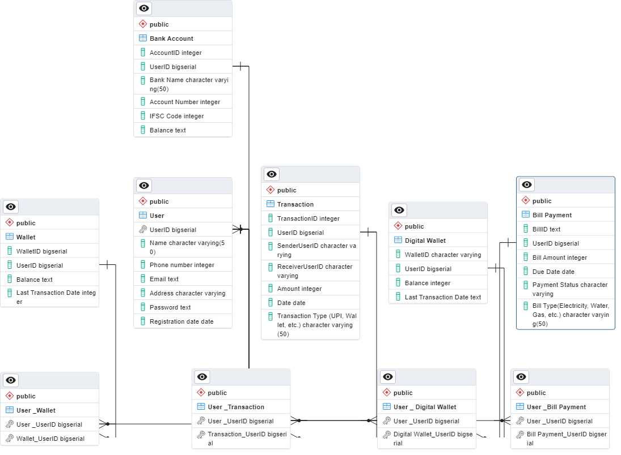

### **Conclusion:**

**To conclude, an ER diagram for PhonePe should effectively capture the essential components of the system, providing a visual representation of how entities are related and how data is organised. The specifics of the diagram would depend on the features and functionalities of the actual PhonePe system and its database design.**